Canadian Parliament, Peace Tower
There are four carvings representing owls located on the Peace tower. The first two are carved on either side of the south arch of the Peace Tower.
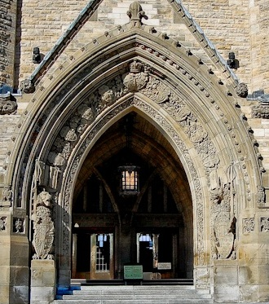
One is located to the right of the Unicorn's head
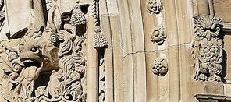
One is locate to the left of the Lion's head.
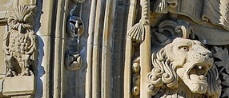

Reliefs
There are a number of decorative relief carvings that can be found on the many friezes on the Peace Tower. These have been sculpted from Wallace sandstone (olive green) from Wallace, Nova Scotia, Canada and vary in size. There is one with two stylized owls.
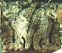
This one can be found on the decorative frieze on south facade of the tower between the double arched windows and the four long arched windows.
